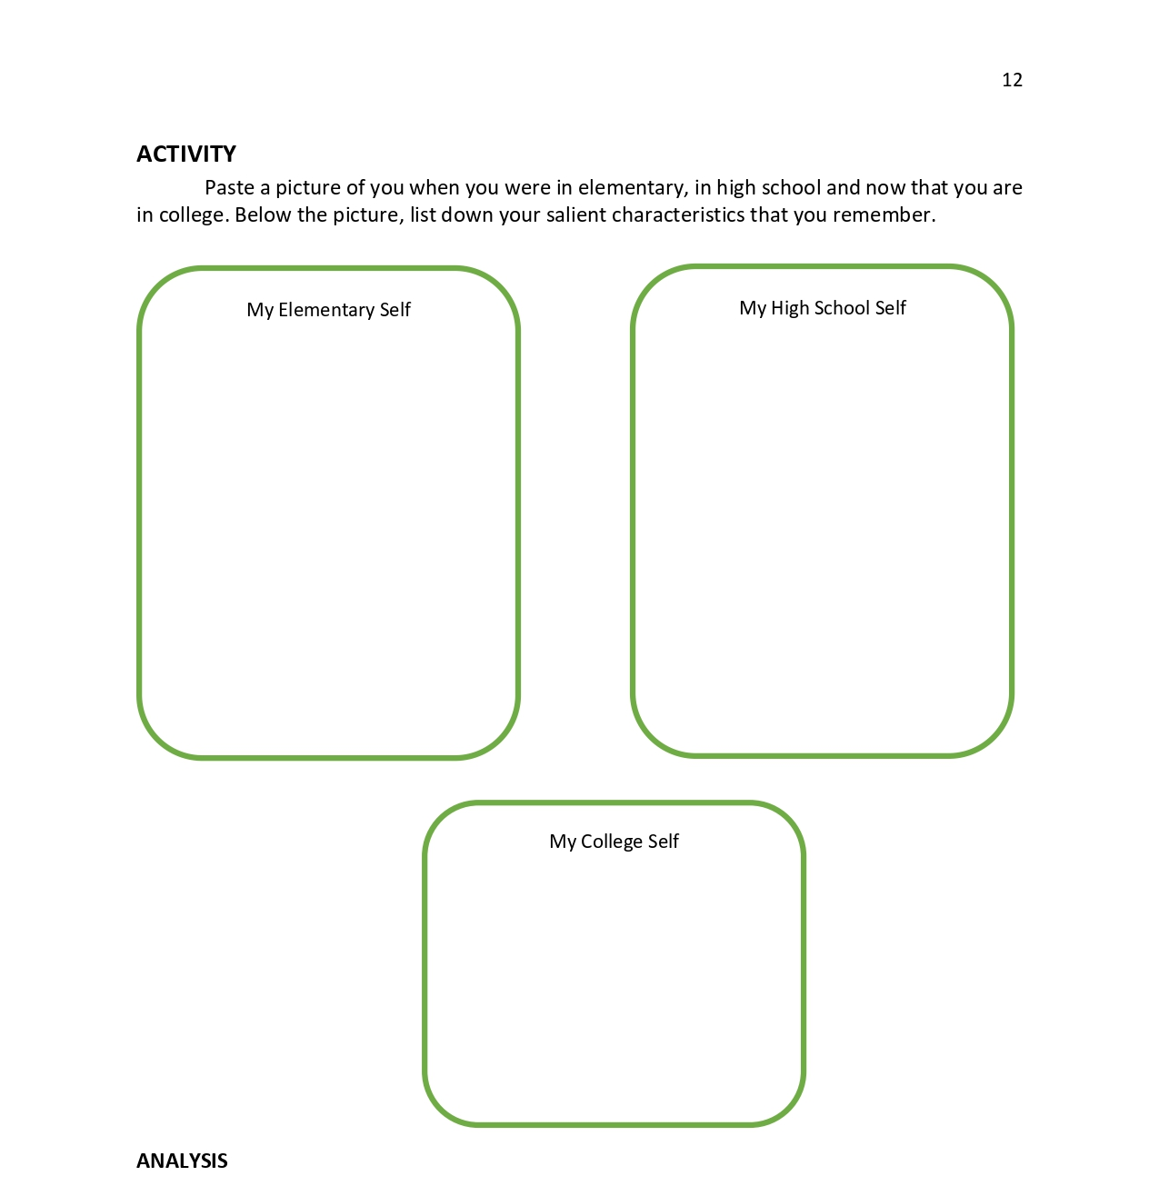

Similarities in All stages of My “Self” | Differences in My “Self” across the Three stages of My life | Possible reason for the Differences in Me
After having examined your “self” in its different stages, fill out the following table:

A Portrait of Yourself
• The best thing(s) I ever did was (were) _________________________________________
• I wish I could lose my fear of _________________________________________________
• I know I have the talent to ___________________________________________________
• I enjoy people who ________________________________________________________
• I admire _________________________________________________________________
• I feel most productive when _________________________________________________
• I am motivated by _________________________________________________________
• I almost never____________________________________________________________
• My idea of fun is __________________________________________________________
• Work is exciting when ______________________________________________________
• The best advice I ever got was _______________________________________________
• The thing I value most is ____________________________________________________
• If money were no object, I would _____________________________________________
• It is easy for me to focus on _________________________________________________
• My idea of perfect life is ____________________________________________________
• My best days are __________________________________________________________
• My dream is ______________________________________________________________
• I always wanted to ________________________________________________________
• I look forward to __________________________________________________________
• I spent too much time ______________________________________________________
• The thing my friends like about me is __________________________________________
• When I try to change something ______________________________________________
• In a group I like to _________________________________________________________
• If I ever win a prize, it will be for ______________________________________________

MY LIFELINE – IMPORTANT PEOPLE AND EXPERIENCES

1) Who are the important people that have helped shape who you are today?
2) What are the important life experiences that changed you in some way?
3) What have you taken forward into your life (attitudes, behaviors, beliefs)?

